MATHEMATICS SPECIALIST 3CD

INTEGRATION BY PARTS

Can you determine 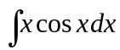 ?
One possible method would be trial and error. Obviously the appropriate result would
have the form x sin x
Test this by differentiating with respect to x which results in the expression
1.sin x + x cos x
which looks right but has the extra term sin x.
Try x sin x + cos x
Testing this by differentiating with respect to x results in the expression
1.sin x + x cos x – sin x or x cos x as required.
∴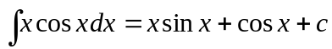
1. [3 marks ]

Determine 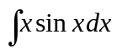
Try x cos x: Differentiating gives 1. cos x + x . (-sin x )
Try -x cos x + sinx : Differentiating gives (-1) . cos x - x . (- sin x ) + cos x
or x sin x
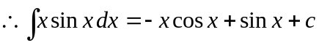


An alternative method for finding integrals of this type utilises the product rule.
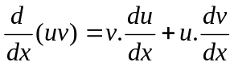
Integrating with respect to x gives
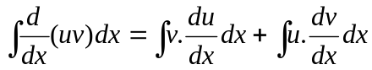
ie 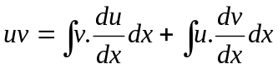 or rearranging
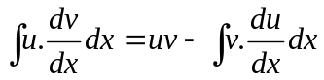.
To use integration by parts to determine
Let u = x and 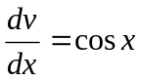
then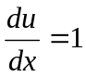 and v = sin x (neglecting the constant term)
Using
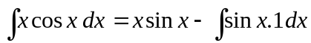
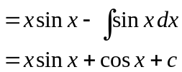
as before.

- [4 marks ]

Show that the result would not change if we used v = sin x + k in place of
v = sin x.
Let u = x and
then and v = sin x + k
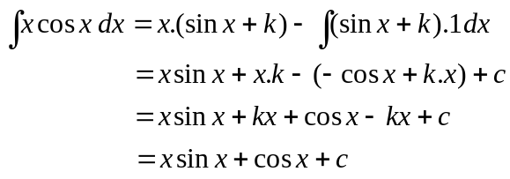





Generally u is the function which produces a simpler result when differentiated while 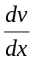 is the more complex part which can still be integrated.

Integrate by parts, each of the following.

3. [4, 4, 4, 4, 4, 8 marks ]

(a) 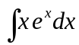
Let u = x and 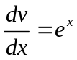
then and 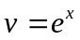
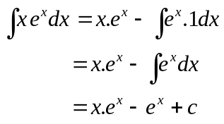






(b) 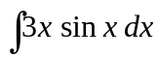
Let u = 3x and 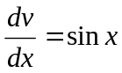
then 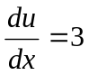 and
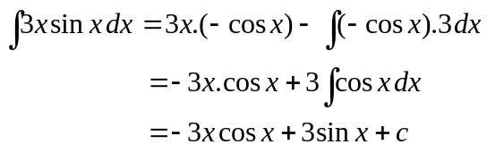






(c) 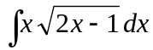
Let u = x and 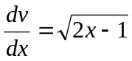
then and 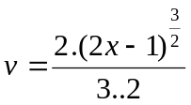
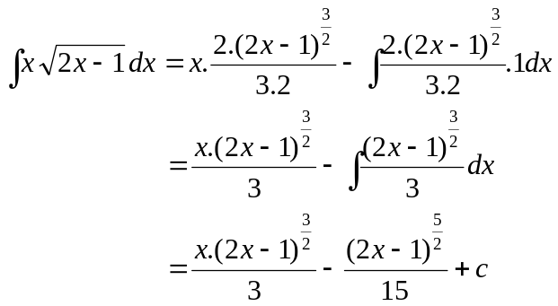






(d) 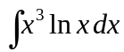
Let u = ln x and 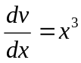
then 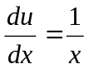 and 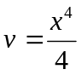
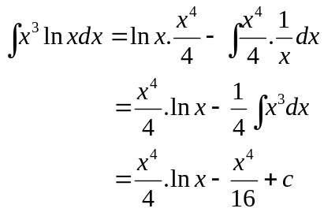






(e) 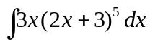
Let u = 3x and 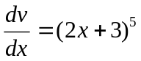
then and 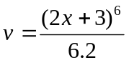 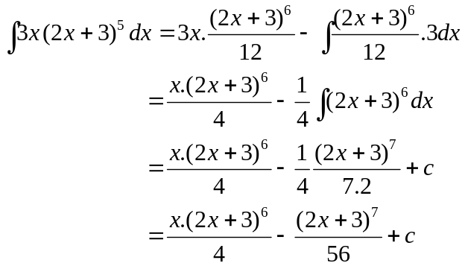






(f) 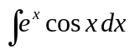 using u = e^{x} and
Let u = e^{x} and
then 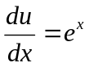 and 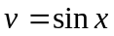
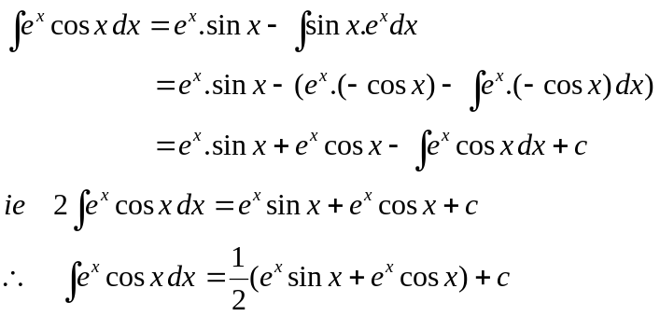









IMPORTANT RESULTS:
